**Responds to reviewer #1:**

We truly appreciate your detailed comments which are valuable for us to improve the manuscript. Your comments are replied as follows:

**Technical suggestions and comments**

1. Q: The choice of clutch times still needs to be better justified. You noted in your response that the time delays were determined 'empirically', but this is still not explained in the manuscript. Additionally, what does 'empirically' mean? How did you know you had a 'good' choice? You've also referenced a mechanical delay - why does this delay exist, and why was it not possible to characterise it?

A: First, as shown in Table 2, most of the timings need not to be accurately determined, so we have some room for uncertainties. This is why we were able to use this vague time delay method in this current prototype. The “empirically” means the delays are roughly guessed from the step frequency, then they were determined and justified by a “trying and adjusting process”. We add the following sentence in the last paragraph in Section 2.4: “The choices of time delays are justified by wearers walking with the exoskeleton in a natural manner.”

On the other hand, we must admit this control scheme needs to be better designed in future work, such as using an IMU as discussed in the “conclusions and future work” section. Also, as you said, we should actually measure the mechanical delay rather than solve every unknown through “trying and adjusting”, this should also facilitate more accurate control of the clutches.

1. Q: Data for the left leg has been presented, which is appreciated. However, it is written in the text that "no significant differences were found among the three conditions for the left leg" - how was this evaluated?

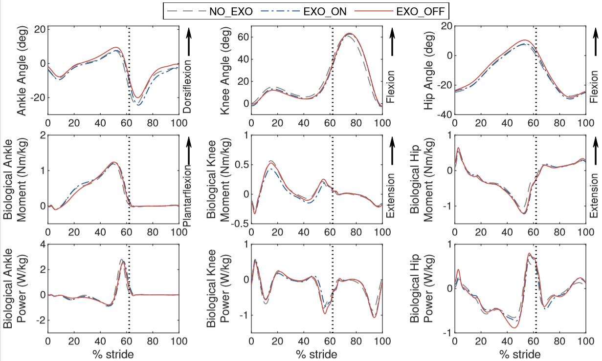

A: We picked out the data which appeared very different (e.g. the hip power at around 45% of the gait cycle) in the above figure, and used ANOVA to test their differences. The results showed no significant differences in all the data points we tested, which covered most of the discernable different data points in the figure.

This is made explicit in Section 3.4.6 in the revised manuscript.

1. Q: How did you calculate the power without the upper body? Wouldn't movement of the torso result in changing of power?

A: The power we calculated is joint power, the calculation method is included in the third paragraph in Section 3.2. Specifically, the joint power was calculated by the dot product of the joint velocity and joint moment. The joint velocity was directly obtained from the markers; the joint moment was calculated by analyzing the dynamics of each segment from the distal to proximal. For example, the ankle moment was calculated using the accelerations of the foot and the ground reaction force, and the knee moment was calculated using the accelerations of the shank and the ankle moment, etc. Therefore, the torso is not needed in the calculation of joint power.

1. Q: Is a warm up period of "one or two minutes" sufficient to ensure that the subjects had adopted a consistent gait and one that is representative of consistent use?

A: This is debatable, and we think no conclusive answer can be given. Considering that the subjects had practiced walking with the exoskeleton (on and off) each for twenty minutes the day before data collection, we would like to say the subjects had learned to walk with a consistent gait. The experimental results showed that most of the subjects' gait is stable after a short warm-up. We also admit that the “one or two minutes” is not to be understood in the strict sense, but adjusted according to the feedback of the subjects.

**Presentation comments and suggestions**

1. Q: Whilst the addition of an expected results section is welcome - the following Results and Discussion section does could be more strongly related/linked to those expected outcomes. For example, 3.4.1 describes the forces in the ropes, but does not directly address the expected outcomes. I would suggest that this section could be further restructed by first presenting the results which address these expected outcomes, and then introducing supplementary material as a discussion.

A: Thank you for this suggestion. We put the “Lost Energy due to Elastic Anchor” as the last part in the result section (3.4.6), and maintained the order for other sub-subsections. The reason is this: we want to first verify the functionality of the electro-mechanical system of the exoskeleton, therefore we put the rope force as the first result (3.4.1). Than as a usual way to present experiment data, we put the kinematics result (3.4.2) before the dynamical analysis results. Also, it is logically more natural to first present the moment and power given from the exoskeleton to human (3.4.3), and then how human joint dynamics changed with the exoskeleton (3.4.4). This motivates the arrangement for the result section.

To remedy that the change of joint dynamics (3.4.4) is a little bit far from the expected outcomes (3.3), we add sentences in (3.4.4) to explicitly correspond the respective part of results to the specific expected outcome.

1. Q: Figure 10 and Figure 11 seem to be presenting different parts of the stride as 0%. Figure 10 shows has the start of each step in the swing phase, whereas Figure 11 starts the gait cycle in the stance phase. This is confusing for the reader.

A: We apologize for the confusion, yet we think it is reasonable to do so. In figure 10, we aim to demonstrate how the energy was stored and released by the torsion spring, so we start from the time when the spring begins to be stretched by the knee in swing phase, and end at the time when the energy is fully released at toe off. On the other hand, in figure 11 and 12, we aim to show how the exoskeleton interacts with human, so we adopt the usual presentation of experiment data from heel strike to the next heel strike.

1. Q: Language still needs revising. There are numerous grammatical errors on the first page alone, and this continues reguarly throughout the paper. For example:

- Page 1, Column 2, Paragraph 1: "These exoskeletons do not directly provide external energy to human" -> "to the human user".

- Page 1, Column 2, Paragraph 3: "The spring in theory do not" -> "the spring in theory does not"

- Page 1, Column 2, Paragraph 3: "Energy storage and return is also a strategy utilized by human...." -> utilized by humans

A: We are extremely sorry for our carelessness, this time we have carefully checked the grammar and made our best efforts to eliminate mistakes.

1. Q: The change to a stride frequency does make sense, although further alignment with the units would further ease the understanding of the work. The majority of the work refers to periods of the gait cycle in percentage (e.g. Figure 5 has the swing phase as the first 40% of the gait cycle). It would make sense to explain the clutch actuation timings (or desired timings) as the same.

A: Thank you for this nice suggestion, the clutch timings expressed as the percentage of a gait cycle have been added to Table 2. Also, to make things more consistent and easier for readers to understand, the percentage labels in Fig. 5 are now changed to 60%-0%(100%)-60%, because everywhere else we refer “percent” with respect to a gait cycle from heel strike to the next heel strike.

1. There are still some statements which are unclear. For example, in 3.4.1, the statement "The average peak force in the knee rope (blue line) was 55/pm 6 N, indicating the spring was stretched to recycle energy from the knee joint in late swing." I am not sure how the level of the force indicates that energy was recycled?

A: We have modified the sentences to more accurately convey the idea. For example,

“The average peak force in the knee rope (blue line) was 55 \pm 6 N, indicating the spring was stretched by the knee joint, and therefore some energy was stored in the torsion spring in late swing.”

“In the second stage, the slope became milder, indicating the spring was stretched again by the ankle and began to store energy.”

We think “store” is a safer word than “recycle” in this context.